Body of the Report
Responses to Covid-19 outbreak
In January 2020, the number of cases of Covid-19 increased across the cities and provinces in China. In accordance with Professor Li Lanjuan, the National Health Commission convened professional experts to assess the ramifications of her proposal that the last resolution in containing the epidemic was implementing a lockdown on Wuhan. The authorities issued a notice to halt down all the normal traveling routes and activities within Wuhan. It is reported that approximately 300,000 Wuhan residence fled by train to other cities prior to the lockdown. Finally, on 23rd January 2020, China's central government imposed Wuhan lockdown and other neighboring cities as a protective measure to quarantine the epicenter of Covid-19. This move which was acknowledged by the World Health organization was termed as "unprecedented in public health industry"
The figure bellows shows the timeline for Covid-19 from 2019 to 2020.
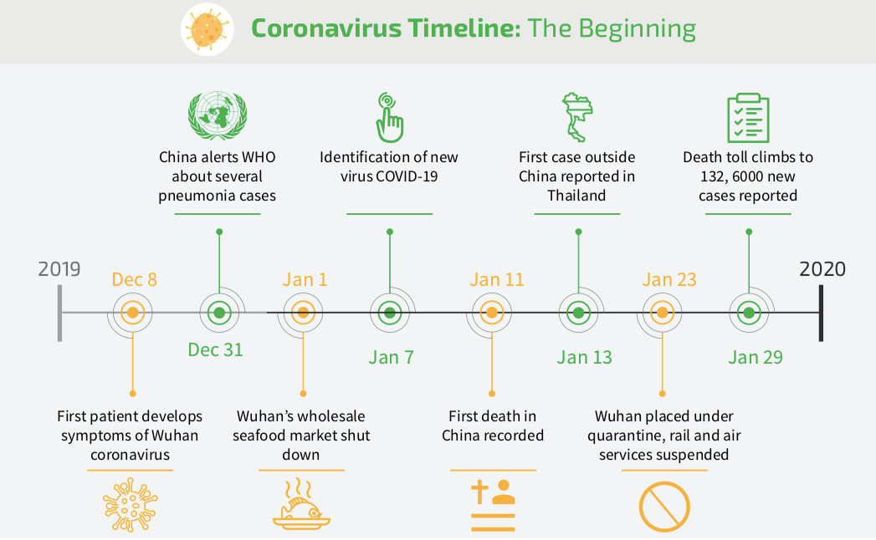
Source: https://www.weforum.org/agenda/2020/04/coronavirus-spread-covid19-pandemic-timeline-milestones/
Global Response to the Pandemic
Countries are swiftly implementing measures to slow down the transmission of Covid-19 through testing and treating the identified victims, deploying contact tracing, limiting travel arrangements, quarantining the individuals, and cancellation of large gatherings, for instance sporting events. The communities are adopting non-pharmaceutical public interventions (NPIs) to assist in slowing the spread of the infections. Since this pandemic flu is new and there is no known vaccine and the human population have minimal or lacks immunity against it, then NPIs are the best strategy of controlling the pandemic virus, especially in the absence of the vaccines.
In accordance with the World Health Organization, infection chance can be reduced through:
- Washing hands using alcohol-based sanitizers, or washing the hands with running water and soap.
- Maintenance of minimal distance of one meter between two people
- Avoiding crowded environments
- If an individual has minor symptoms the individual should stay at home and self-isolate
- Every person should adhere to good respiratory hygiene.
Contact tracing is one of the old aged strategies utilized in controlling the spread of the disease. The technique has been successful in containing SARS, MERS, Ebola, and Tuberculosis, among others. This strategy commences with the people who have tested positive for the Coronavirus. The people who have close contact with the infected person are also identified. The contacts are usually supported during the quarantine period until they surpass the risk window or develop symptoms or proven not to be exposed. Extensive testing facilitates effective contact tracing optimally.
The high intensity, as well as NPIs durations, have the potential of lowering the cumulative morality theoretically at the cost of the countries' economy.
Figure 3 below shows how contact tracing works.
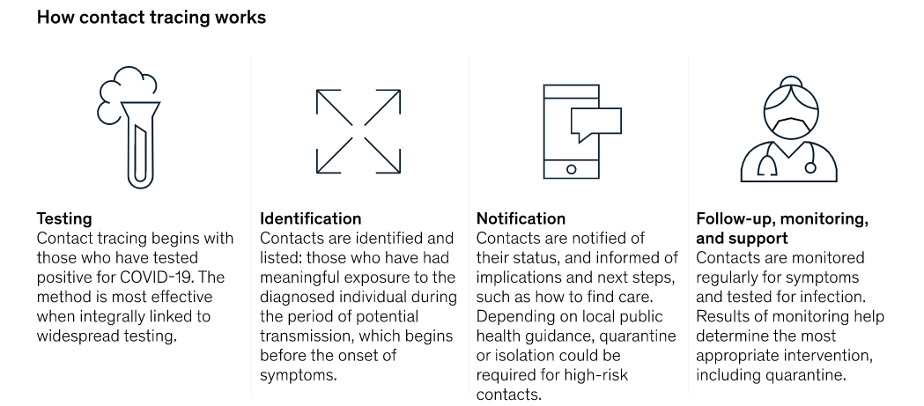
Economic Impact of Covid-19
The Covid-19 pandemic has led to an economic crisis that has posed massive challenges both globally and locally. The pandemic has immediately hit the services as well as manufacturers leading to massive laying off of personnel. The travel industry has not been left behind. It has suffered casualties as several airlines, and the hotel industry is the verge of bankruptcy and collapsing as nations close borders, blocking the movement of publics in containment of the Covid-19 transmission. Other sectors such as tourism, hospitality, other logistics sector have also been affected.
The manufacturing and production industries based on China have been affected heavily. Those in the Asia-pacific region, as well as other regions, have been impacted adversely. Due to the pandemic, there has a surge in demand for health and web-based services, for instance, e-commerce, food deliveries, and online education.
SMEs have been greatly affected considering their limited resources and accessibility to credit for their working capital. SMEs account for approximately 96 % of all business and 67% of the private-sector jobs in the Pacific and Asia. Implementation of viable strategies in reducing the labor market displacement as well as facilitation of labor adaptations could minimize the job losses. The decisions resulted in laying-off, bankruptcies, and disruptions in supply-chains, non-performing loans in the banking industry, increase precautionary savings, and postponed investment strategies causing an adverse demand shock.
Significance of China
China is the largest exporter and importer in the world, and this has greatly affected the countries which depend on China for intermediate inputs. For instance, Apple and Nike are a case example.
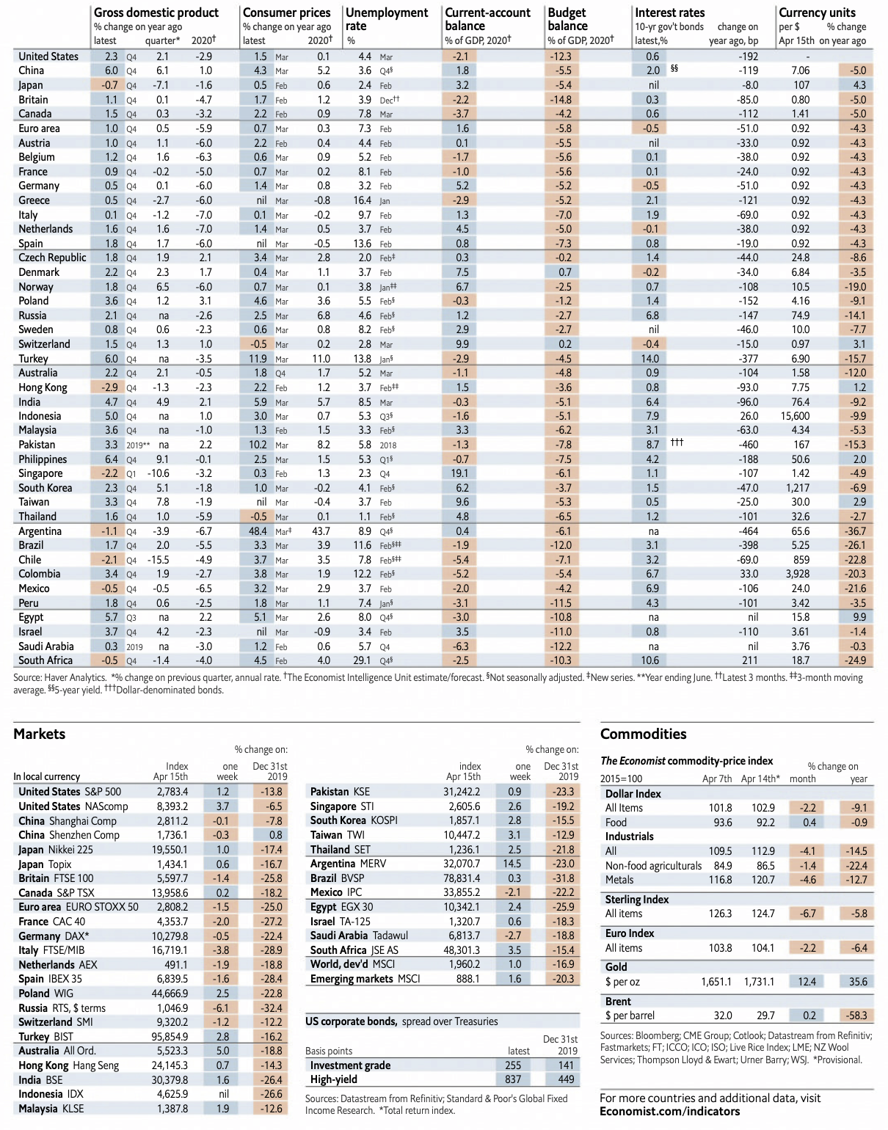

In the previous figure, there was a decrease in the GDP of China within the first quarter, and this is negative news to the whole world since Chin contributes approximately 16 percent to the global economy. Prior to the pandemic, the approximated GDP of the first quarter in China was 6 percent.
Relevant Business and Economic data
The economic health and business impacts felt across all countries. These include;
- In Europe, the car manufacturers that are Ferrari and Volkswagen have suspended their production.
- Tokyo Olympic Games were postponed to 2021
- There is the cancellation of Cruise operators
- There are low estimates of ad revenue for Amazon and Facebook
- In France and Spain, there is a suspension of the Airbus
- There is the closure of casino resorts in the US by MGM
In the EU regions, the borders are being reinstated.

https://en.wikipedia.org/wiki/COVID-19_pandemic_lockdown_in_Hubei
https://www.cdc.gov/nonpharmaceutical-interventions/index.html
https://www.mckinsey.com/industries/public-sector/our-insights/contact-tracing-for-covid-19-new-considerations-for-its-practical-application
https://www.cdc.gov/nonpharmaceutical-interventions/index.html
UNDP (2020). The Social and Economic Impact of COVID-19 in the Asia-Pacific Region. Position Note prepared by UNDP Regional Bureau for Asia and the Pacific. Bangkok: United Nations Development Programme.
Hausmann Harvard GL - Saudi Arabia Covid-19 Oil Price
Economic effects of coronavirus outbreak (COVID-19) on the world economy Preliminary and subject to revisions as new data is released Revised, April 13, 2020 Version 2.0
Economic effects of coronavirus outbreak (COVID-19) on the world economy Preliminary and subject to revisions as new data is released Revised, April 13, 2020 Version 2.0

